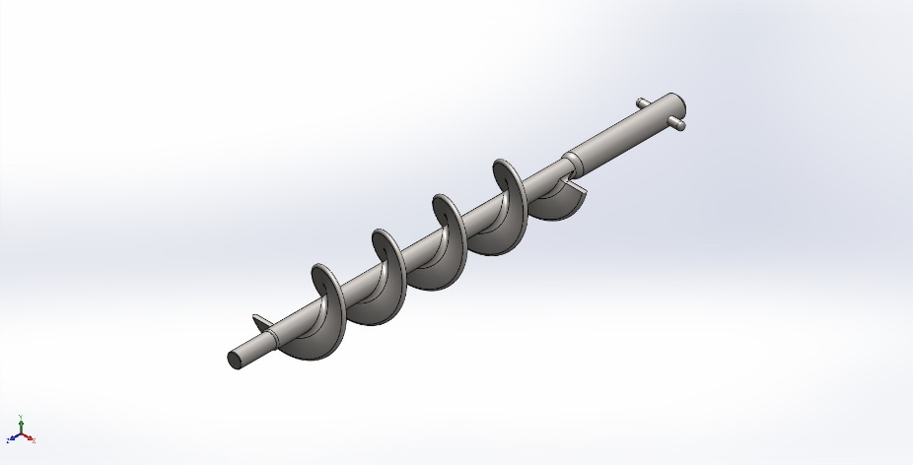
  Simulation of 0.Auger (الطول الكلي 444سم)
  Date: Saturday, January 3, 2026
  Designer: Solidworks
  Study name: Auger static analysis
  Analysis type: Static
  Table of Contents
  Description 1
  Assumptions 2
  Model Information 2
  Study Properties 3
  Units 3
  Material Properties 4
  Loads and Fixtures 4
  Connector Definitions 5
  Interaction Information 5
  Mesh information 5
  Sensor Details 5
  Resultant Forces 6
  Beams 6
  Study Results 7
  Conclusion 9

Description
No Data

Assumptions

Model Information

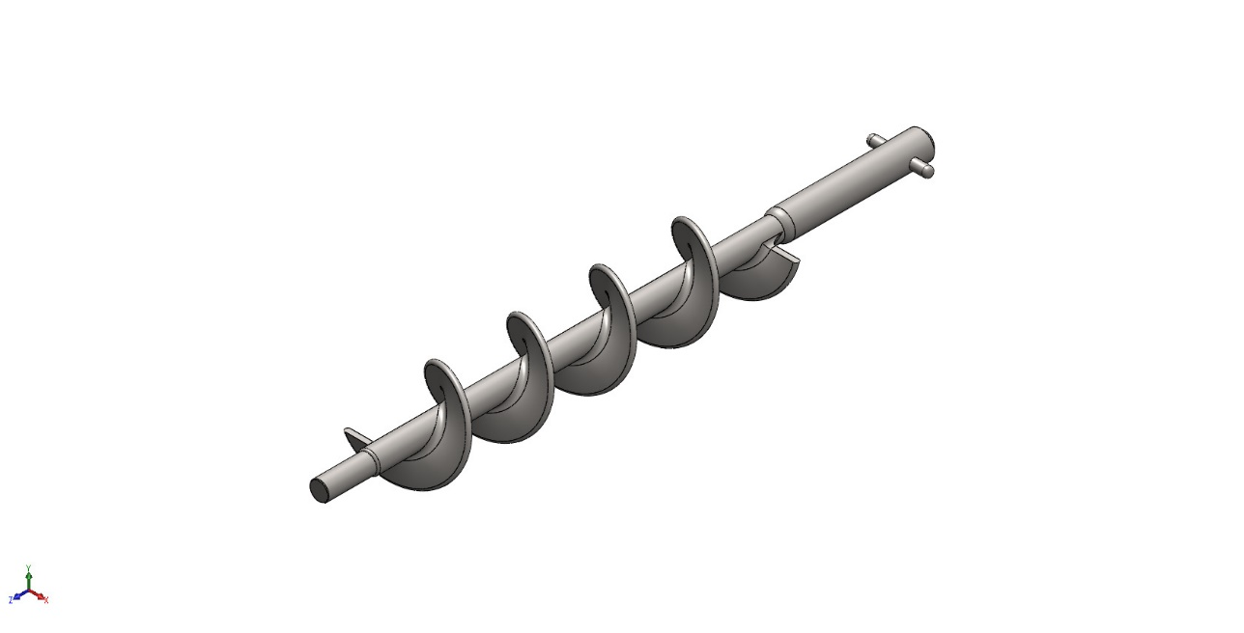
Model name: 0.Auger (الطول الكلي 444سم)
Current Configuration: Default
Solid Bodies
Document Name and Reference | Treated As | Volumetric Properties | Document Path/Date Modified
Fillet16  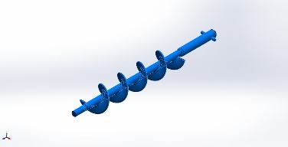 | Solid Body | Mass:1.17612 kg  Volume:0.000147026 m^3  Density:7,999.35 kg/m^3  Weight:11.5259 N | C:\Users\user1\Desktop\0.Auger (الطول الكلي 444سم).SLDPRT

Study Properties
Study name | Auger static analysis
Analysis type | Static
Mesh type | Solid Mesh
Thermal Effect: | On
Thermal option | Include temperature loads
Zero strain temperature | 298 Kelvin
Include fluid pressure effects from SOLIDWORKS Flow Simulation | Off
Solver type | Automatic
Inplane Effect: | Off
Soft Spring: | Off
Inertial Relief: | Off
Incompatible bonding options | Automatic
Large displacement | Off
Compute free body forces | On
Friction | Off
Use Adaptive Method: | Off
Result folder | SOLIDWORKS document (C:\Users\user1\Desktop)

Units
Unit system: | SI (MKS)
Length/Displacement | mm
Temperature | Kelvin
Angular velocity | Rad/sec
Pressure/Stress | N/m^2

Material Properties
Model Reference | Properties | Components
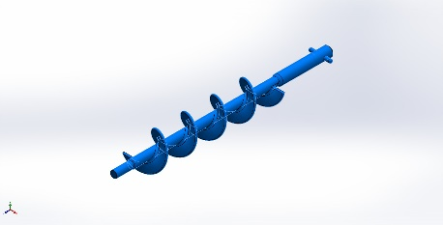 |  | SolidBody 1(Fillet16)(0.Auger (الطول الكلي 444سم))
  Name: | AISI 304
  Model type: | Linear Elastic Isotropic
  Default failure criterion: | Max von Mises Stress
  Yield strength: | 2.06807e+08 N/m^2
  Tensile strength: | 5.17017e+08 N/m^2
  Elastic modulus: | 1.9e+11 N/m^2
  Poisson's ratio: | 0.29
  Mass density: | 8,000 kg/m^3
  Shear modulus: | 7.5e+10 N/m^2
  Thermal expansion coefficient: | 1.8e-05 /Kelvin
Curve Data:N/A

Loads and Fixtures
Fixture name | Fixture Image | Fixture Details
Fixed-1 | 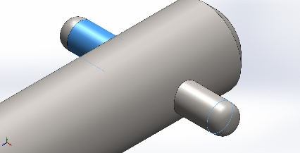
  Entities: | 1 edge(s), 1 face(s)
  Type: | Fixed Geometry
Resultant Forces
Components | X | Y | Z | Resultant
Reaction force(N) | -48.1414 | -1.24923 | 0.00227994 | 48.1576
Reaction Moment(N.m) | 0 | 0 | 0 | 0

Load name | Load Image | Load Details
Torque-1 | 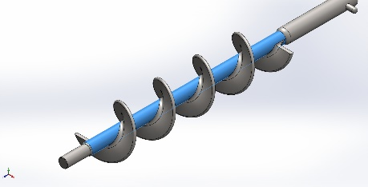
  Entities: | 1 face(s)
  Type: | Apply torque
  Value: | 20 N.m

Connector Definitions
No Data

Interaction Information
No Data

Mesh information
Mesh type | Solid Mesh
Mesher Used: | Blended curvature-based mesh
Jacobian points for High quality mesh | 16 Points
Maximum element size | 5.27908 mm
Minimum element size | 0.474567 mm
Mesh Quality | High

Mesh information - Details
Total Nodes | 84219
Total Elements | 50377
Maximum Aspect Ratio | 88.261
% of elements with Aspect Ratio < 3 | 99.6
Percentage of elements with Aspect Ratio > 10 | 0.00993
Percentage of distorted elements | 0
Time to complete mesh(hh;mm;ss): | 00:00:19
Computer name:

Sensor Details
No Data

Resultant Forces

Reaction forces
Selection set | Units | Sum X | Sum Y | Sum Z | Resultant
Entire Model | N | -48.1414 | -1.24923 | 0.00227994 | 48.1576

Reaction Moments
Selection set | Units | Sum X | Sum Y | Sum Z | Resultant
Entire Model | N.m | 0 | 0 | 0 | 0

Free body forces
Selection set | Units | Sum X | Sum Y | Sum Z | Resultant
Entire Model | N | 0.364388 | 0.015881 | 0.906562 | 0.977183

Free body moments
Selection set | Units | Sum X | Sum Y | Sum Z | Resultant
Entire Model | N.m | 0 | 0 | 0 | 1e-33

Beams
No Data

Study Results

Name | Type | Min | Max
Stress1 | VON: von Mises Stress | 3.989e+00N/m^2  Node: 25227 | 9.973e+07N/m^2  Node: 81630
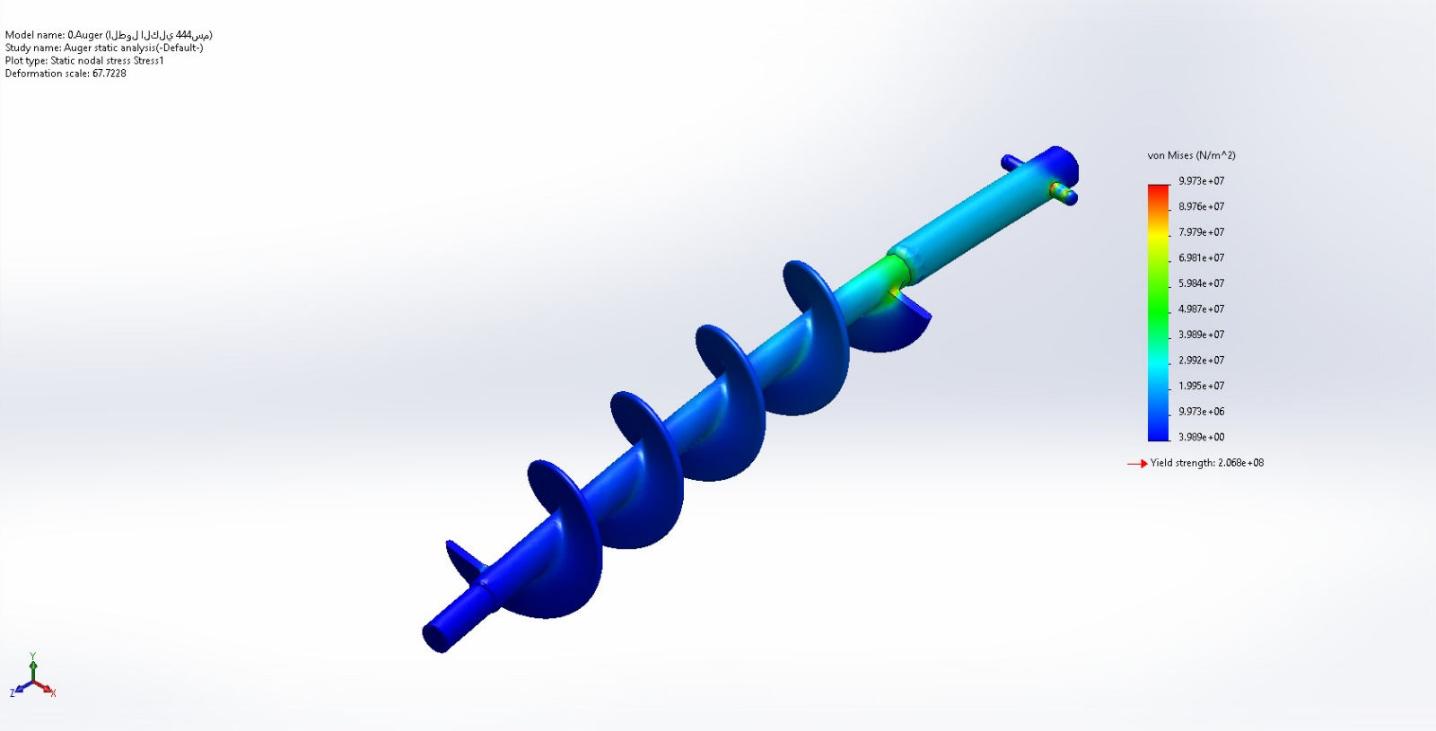
0.Auger (الطول الكلي 444سم)-Auger static analysis-Stress-Stress1

Name | Type | Min | Max
Displacement1 | URES: Resultant Displacement | 0.000e+00mm  Node: 36 | 7.087e-01mm  Node: 60633
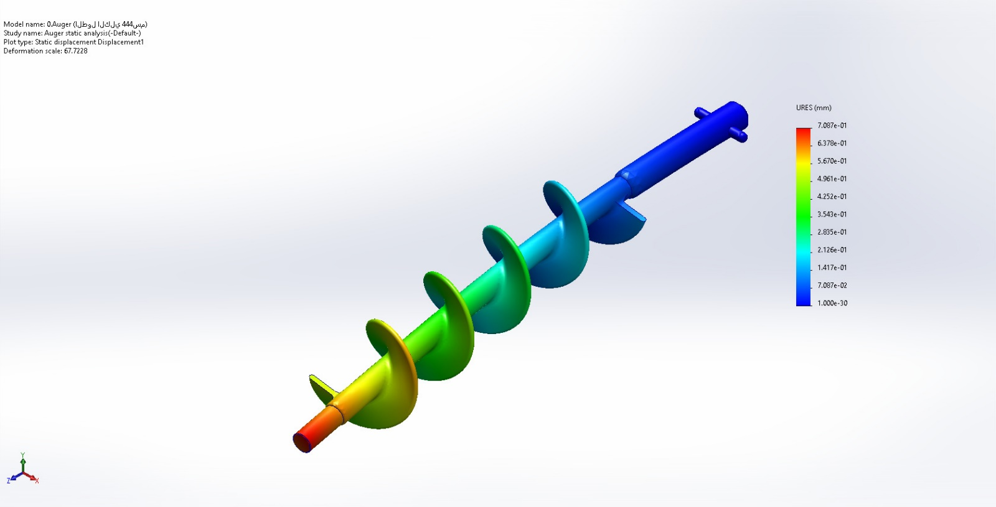
0.Auger (الطول الكلي 444سم)-Auger static analysis-Displacement-Displacement1

Name | Type | Min | Max
Strain1 | ESTRN: Equivalent Strain | 1.449e-11  Element: 1559 | 3.942e-04  Element: 38209
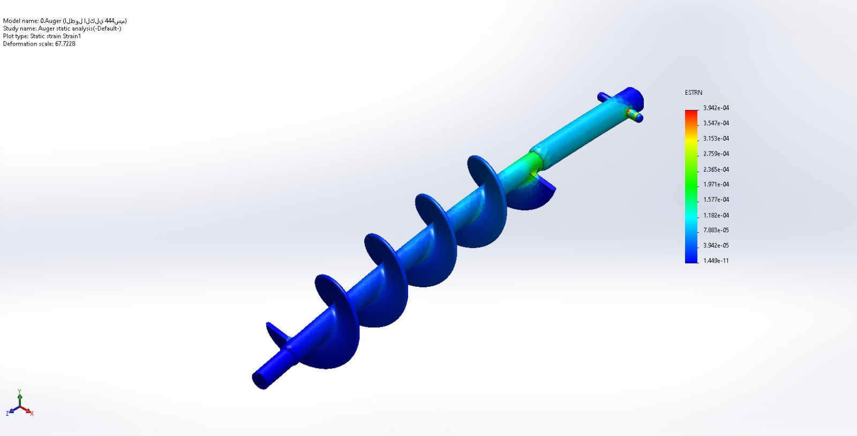
0.Auger (الطول الكلي 444سم)-Auger static analysis-Strain-Strain1

Name | Type | Min | Max
Factor of Safety1 | Max von Mises Stress | 2.074e+00  Node: 81630 | 5.184e+07  Node: 25227
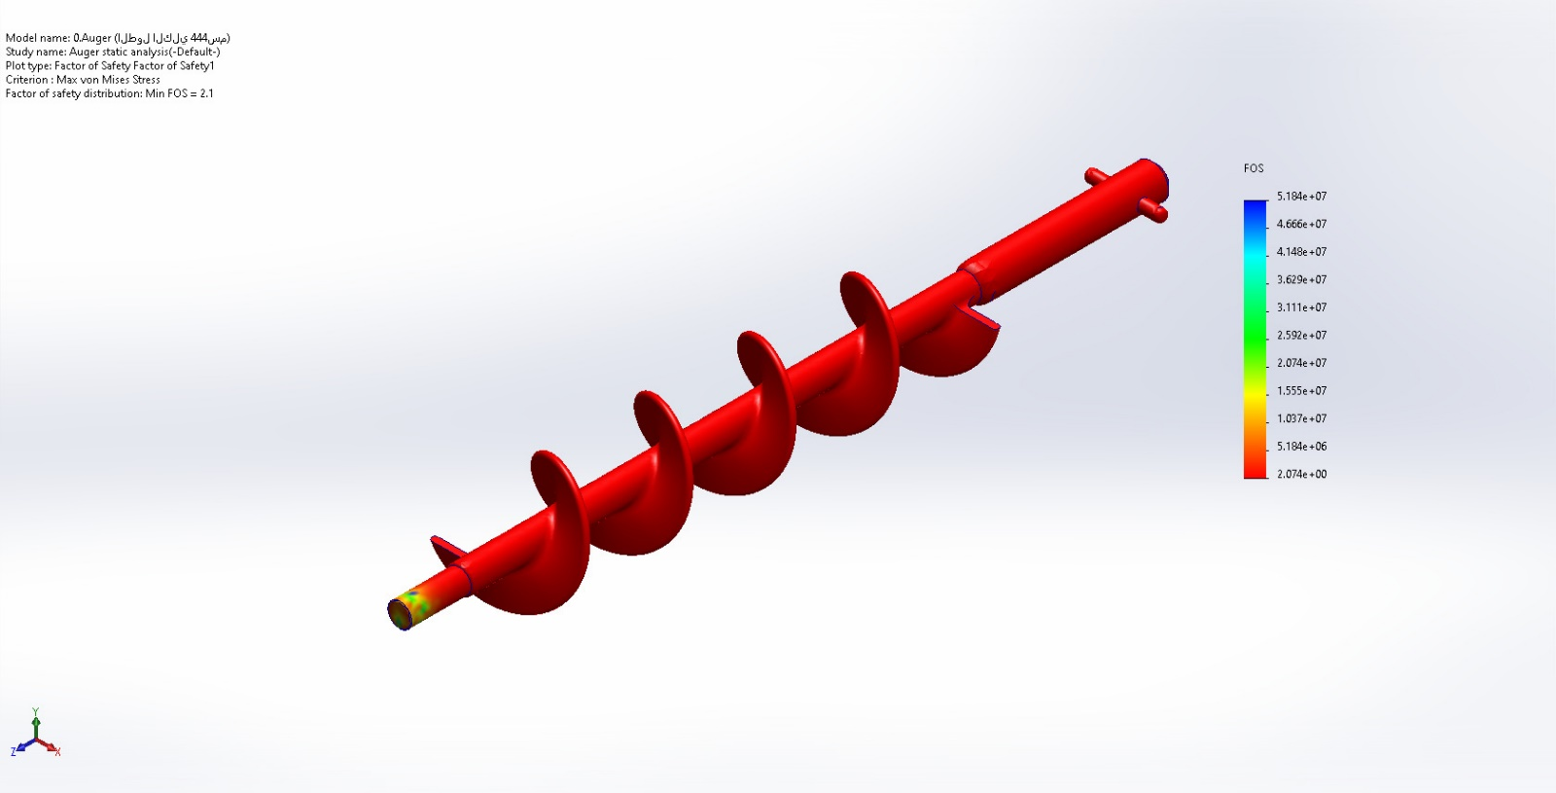
0.Auger (الطول الكلي 444سم)-Auger static analysis-Factor of Safety-Factor of Safety1

Conclusion

